Yang, A regression approach to Music Emotion Recognition

Regression approach is free of the ambiguity inherent to conventional categorical approaches

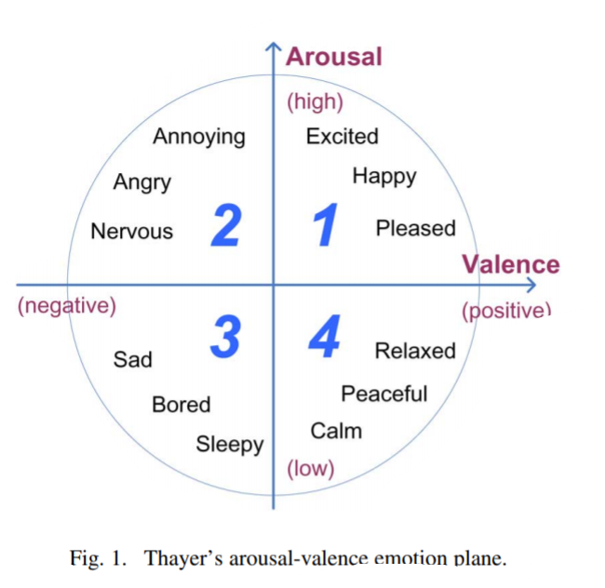

Not easy to describe emotion in a universal way because adjectives used may be ambiguous and can vary from person to person

**Have a look at support vector regression yeah**

Regression theory => predicting a real value from observed variables/ features